1. INTRODUCTION

Overview
Snack Squad is a customizable snack ordering and delivery service that allows customers to create their own snack boxes and have them delivered to their doorstep. The company offers a wide range of snacks, from healthy options like granola bars and fruit to indulgent treats like candy and chips.Customers can create their own snack boxes by choosing from a selection of snacks, which can be filtered by dietary requirements such as gluten-free or vegan. They can also set up a recurring delivery schedule or order on demand.Snack Squad offers a subscription service that provides customers with a discount on their snack boxes and free shipping. The company also has a referral program that rewards customers with free snacks for every person they refer.Snack Squad sources its snacks from a variety of vendors and brands, including small and local businesses. The company prioritizes sustainability and eco-friendliness in its packaging and shipping practices.finally Snack Squad offers a convenient and customizable way for customers to satisfy their snack cravings while supporting small businesses and promoting sustainable practices.

  - Purpose
The purpose of Snack Squad is to provide a customizable snack ordering and delivery service that offers convenience, variety, and sustainability. The company aims to cater to the growing demand for snack options that align with customers' dietary requirements and preferences.By allowing customers to choose from a wide selection of snacks and customize their own snack boxes, Snack Squad provides a personalized and convenient snacking experience. The recurring delivery option and subscription service further enhance this convenience, making it easy for customers to receive regular delivries of their favorite snacks without having to worry about reordering every time.Snack Squad also prioritizes sustainability by sourcing its snacks from a variety of vendors and brands, including small and local businesses, and using eco-friendly packaging and shipping practices. By doing so, the company promotes sustainable consumption and supports local and small businesses.
Snack Squad's purpose is to offer a customizable and sustainable snack ordering and delivery service that caters to customers' preferences and aligns with their value

- PROBLEM DEFINITION & DESIGN THINKING
  - Empathy Map

SAYS  1.Disappointed when no offers/  Delay delivery.  USER | THINKS  1.Which snacks  2.Veg/Non veg
DOES  1.Search Snack  2.Add in cart  3.Payment | FEELS  1.Hungry  2.Tasty  3.Happy

2.2.Ideation & Brainstorming Map

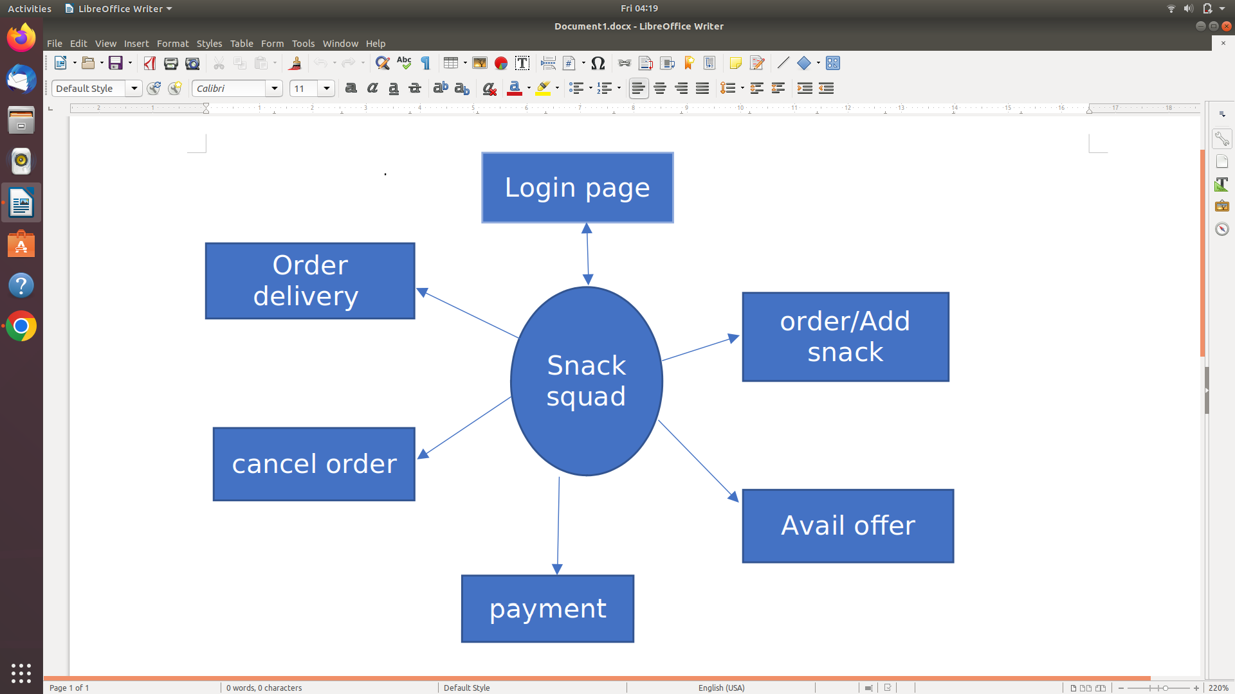

RESULT

Activity & Screenshots

1 .completing task no 1
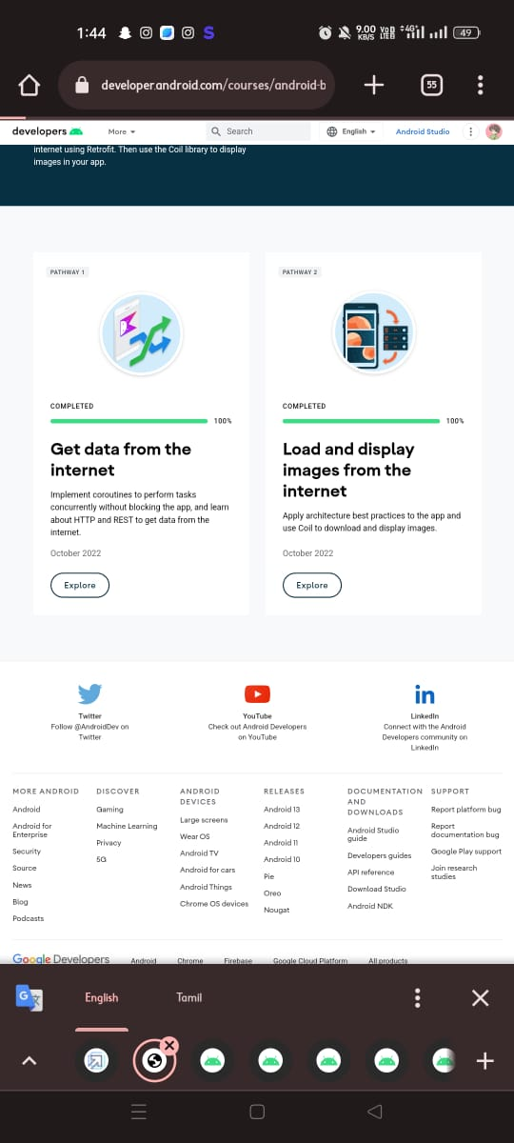

2. completing task 2 . Attending quiz is very interesting
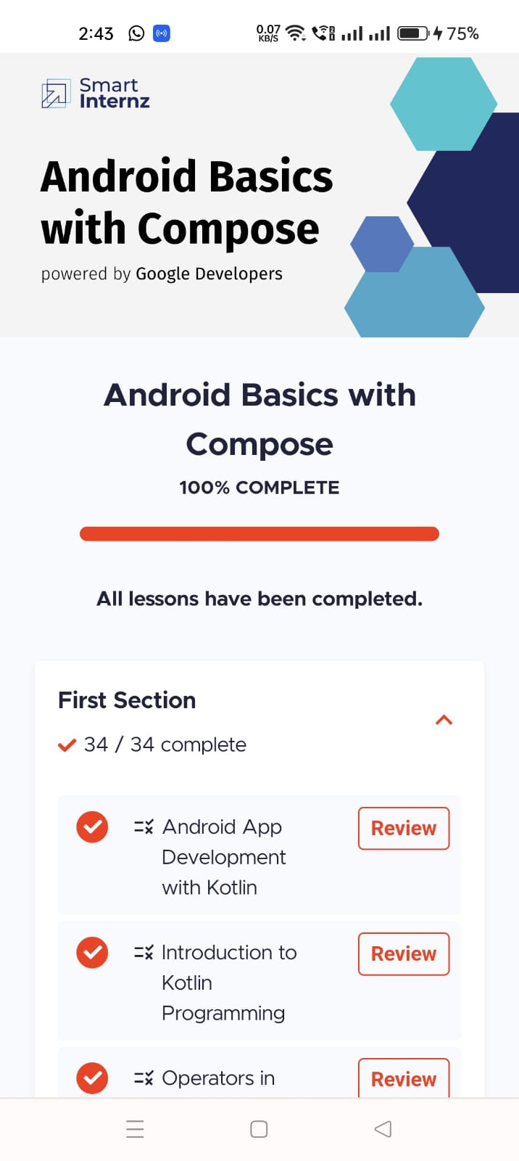

3. reading the project manual to start a project

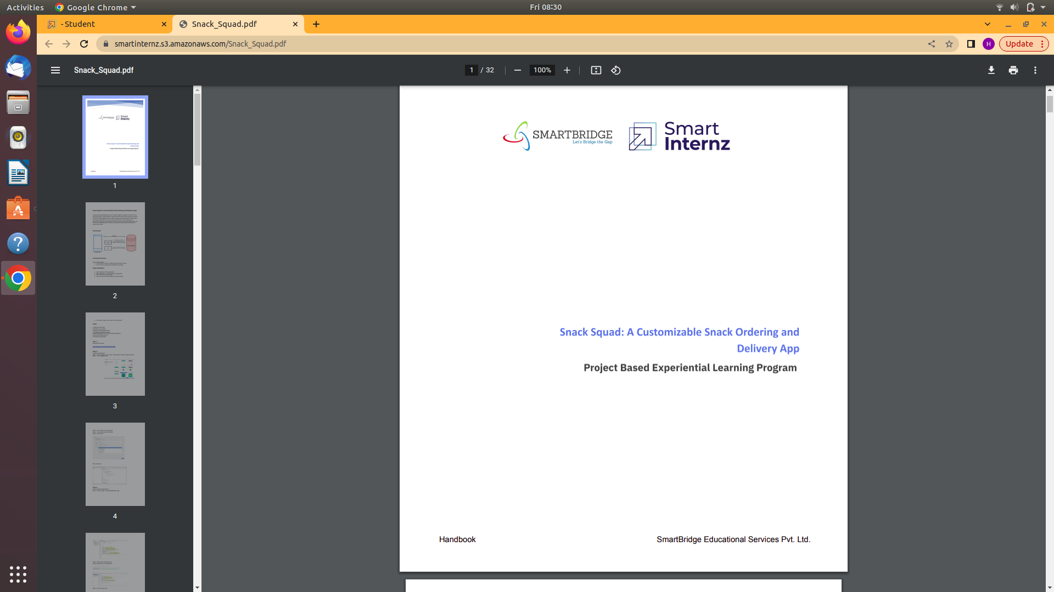

4. Started the task by seeing manual
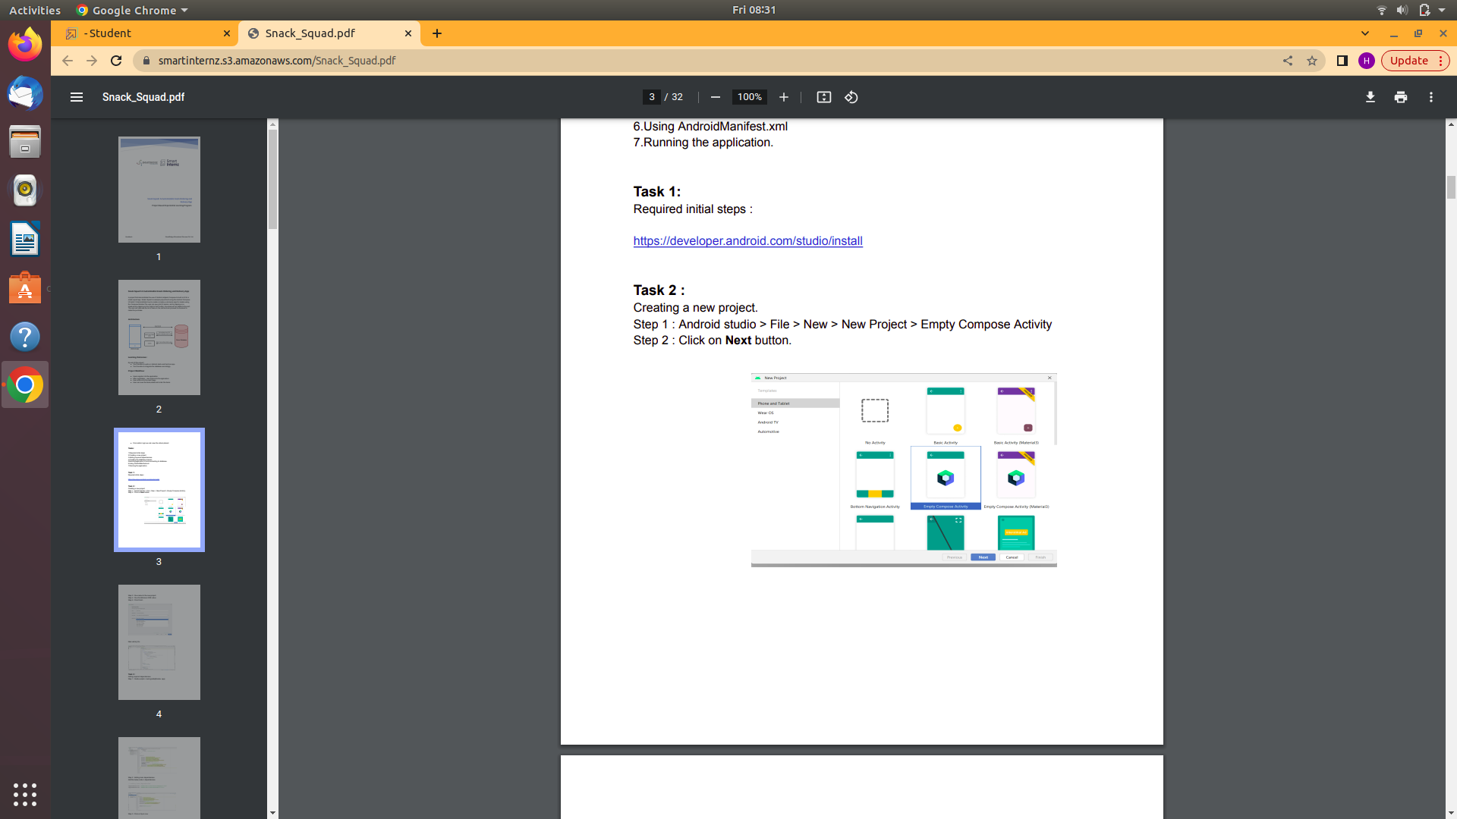

5.Dowloading android studio in the laptop
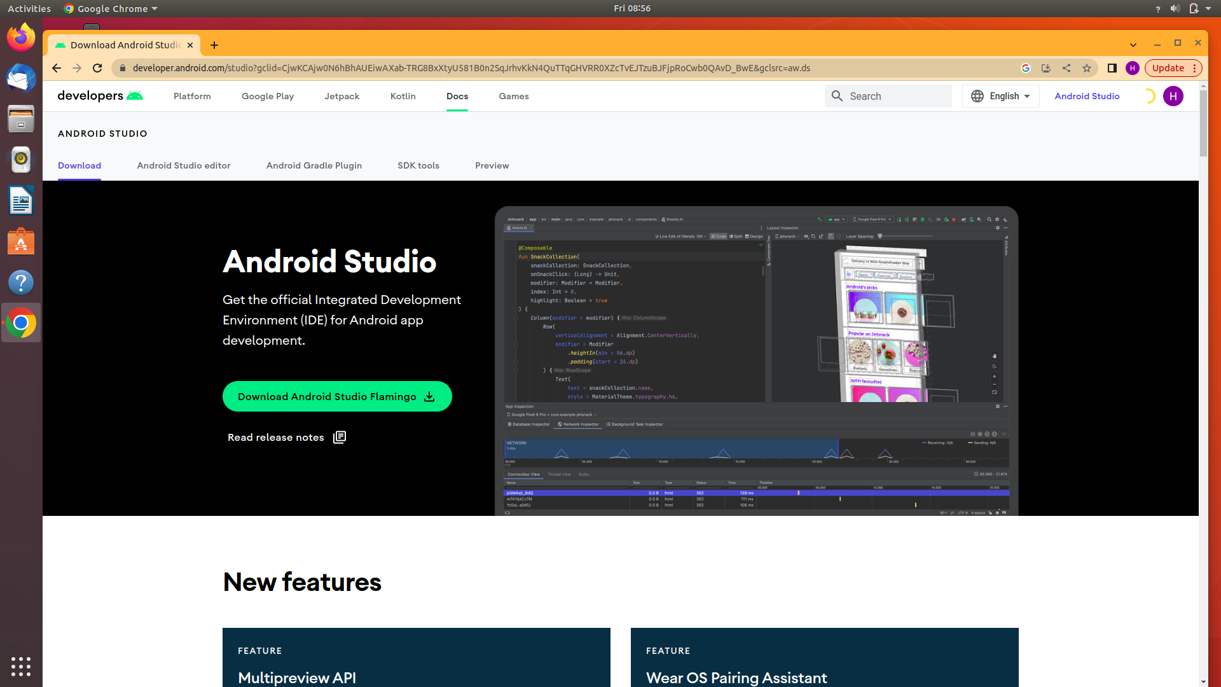

6.Creating database for our project
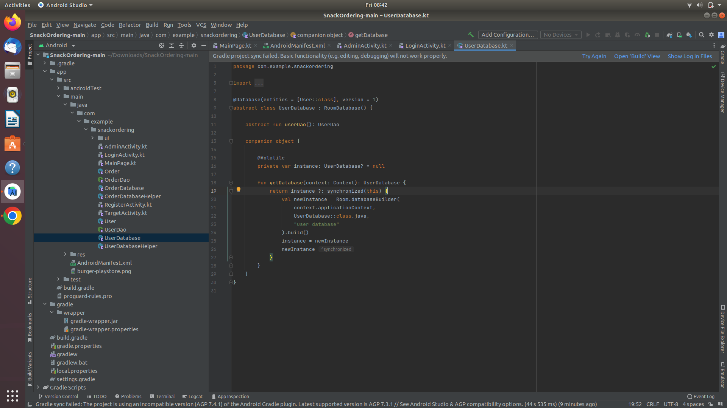

7.Enable developer optin and usb debugging for Connecting mobile phone to laptop

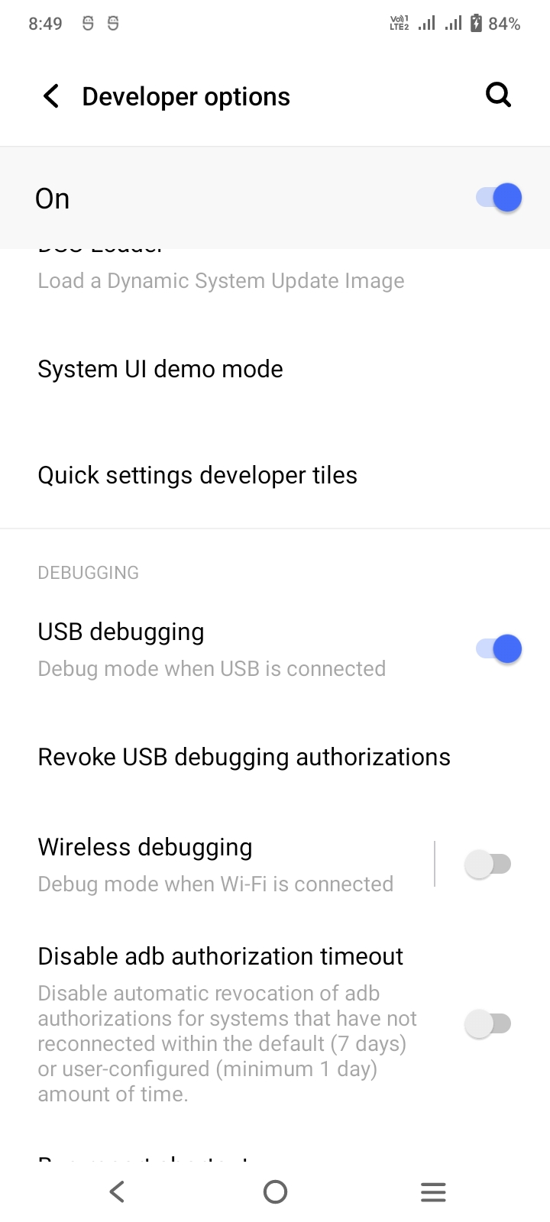

8. Project running

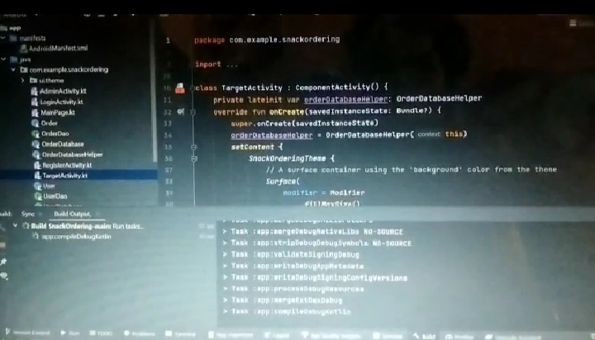

9.Running in mobile phone

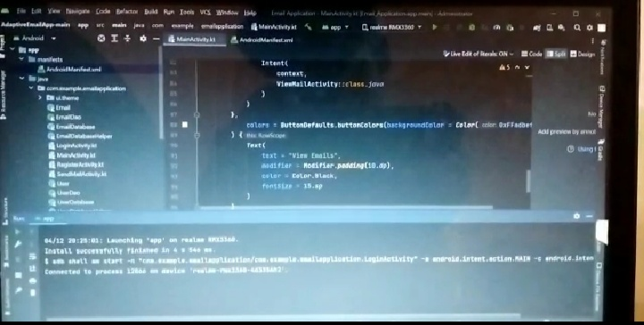

10.PROJECT RUNNING DEMO VIDEO IS PROVIDED IN THE GITHUB LINK ITSELF

11. Completion of project till 90%

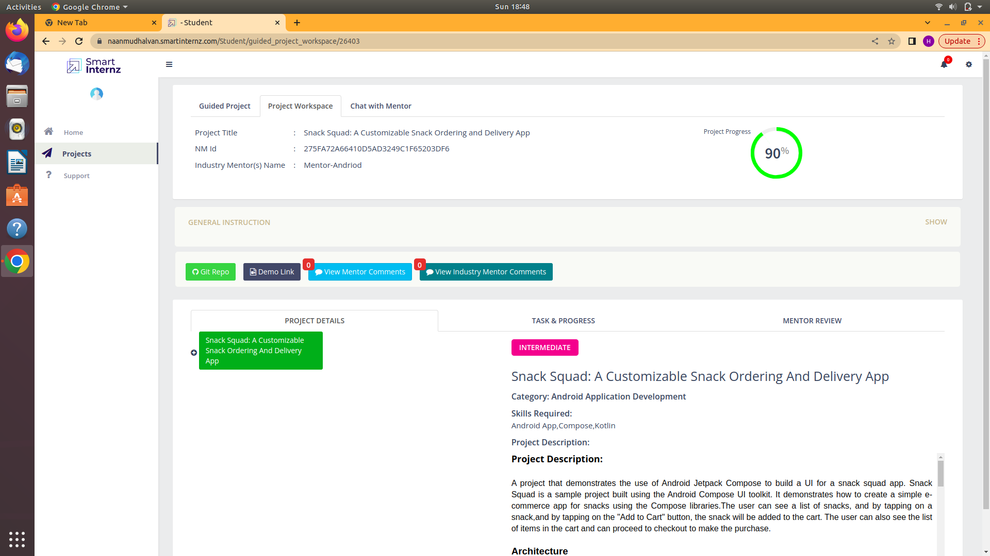

GOOGLE DEVELOPER PROFILE PUBLIC URL

Team Lead - https://g.dev/saiganesh8654
Team Member 1 - https://g.dev/Vimalraj03
Team Member 2
https://g.dev/PARTHIBAN7
Team Member 3 –https://g.dev/AAravind22

- ADVANTAGES OF THIS PROJECT

Customizable : One of the main advantages of Snack Squad is that it offers a high level of customization. Customers can choose from a wide range of snack options and create their own personalized snack boxes based on their preferences and dietary requirements.

Convenience: Snack Squad offers a convenient way for customers to order and receive snack deliveries. Customers can set up a recurring delivery schedule or order on demand, making it easy to get their favorite snacks delivered right to their doorstep.

Variety: Snack Squad offers a wide range of snack options, including healthy and indulgent choices, to cater to customers' diverse preferences and tastes. This variety ensures that there is something for everyone, regardless of their dietary requirements or snack preferences.

Sustainability: Snack Squad is committed to promoting sustainability by sourcing snacks from local and small businesses and using eco-friendly packaging and shipping practices. This commitment to sustainability is an advantage for customers who are looking for ways to reduce their environmental impact.

Discount and referral program: Snack Squad offers a subscription service that provides customers with a discount on their snack boxes and free shipping. Additionally, the company has a referral program that rewards customers with free snacks for every person they refer, which can be a cost-effective way to get more snacks for less.

.

DISADVANTAGE OF PROJECT:
While Snack Squad offers many advantages, there are a few potential disadvantages to using the service:
Limited availability: Snack Squad may not be available in all areas, which could limit access to the service for some customers.
Higher cost: While Snack Squad offers a discount through its subscription service, the cost of the snack boxes may be higher than purchasing snacks from a grocery store or other retail outlet.
Shipping delays: Depending on the shipping method and location, there may be delays in receiving snack boxes, which could be inconvenient for some customers.
Limited snack options: While Snack Squad offers a wide range of snack options, there may be limited options available for customers with very specific dietary requirements or preferences.
Quantity and freshness: Customers may receive snacks that are not as fresh as they would be if purchased directly from a retail outlet. Additionally, the quantity of snacks in each box may not meet the expectations of some customers.
In the end,the disadvantages of Snack Squad are limited availability, higher cost, shipping delays, limited snack options, and potential issues with quantity and freshness.

APPLICATIONS
This application is used to order snacks from anywhere from home/office.

- CONCLUSION
The registered user can able to add the snacks in the cart,order/cancels the orders ,check for offers ,combos and order for the snacks.

- FUTURE SCOPE
In future scope implementation need on Delivery times. Delivery time can often be a major pain point for snack delivery services. Snack Squad could work to optimize its delivery network and technology, making orders arrive faster. This would make the app more attractive to users who want their snacks as quickly as possible.
More Snack Options: While Snack Squad already offers a wide variety of snacks, adding even more options would make the app even more popular. This could include healthier snacks, international snacks, or even rarer snacks that are difficult to find elsewhere.
Personalized recommendations: Snack Squad could use data and artificial intelligence to suggest personalized snacks to users based on their history of ordering, dietary preferences, and other factors. This would make the app even more convenient and useful for those who want to discover new snacks they might not have known about otherwise.
Social sharing features: Adding social sharing features to the app would allow users to share their favorite snacks with friends and followers on social media. This could help increase awareness of the app and attract new users.
Gamification: Adding gamification elements, such as badges or rewards for frequent orders, could help increase user engagement and retention. Overall, by implementing these improvements, Snack Squad could become an even more valuable tool for snack lovers seeking quick and easy access to their favorite eats.

